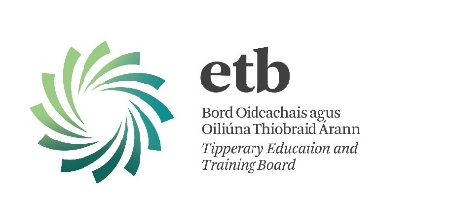
TEACHING AND LEARNING CONTINUES IN TIPPERARY ETB

Released: 30th March 2020

During the COVID19 crisis, TETB will adhere to guidance issued by the Department of Education and Skills and the Health Service Executive. TETB is monitoring the emerging situation and will continue to provide updates as appropriate.
TETB Senior Management Team (SMT) is currently reviewing programme provision with a view to determining the best approach to teaching, learning and assessment. Following this communication will issue to programme managers from the SMT. Programme managers will then liaise with teachers/tutors/adult educators to work with them to support remote teaching and learning and assessment options. Teachers/tutors/adult educators will continue to link with learners to support them with their learning.
TETB will endeavour to facilitate learner assessment requirements as practicable. This may involve using alternative assessment options and/or the option to defer assessment to a later date. Priority at this time will be given to learners who wish to use their QQI certification to progress to HEI. TETB will continue to ensure the preservation of the integrity of the award standards.

TETB encourages all learners to continue to engage with their programmes of learning as guided by your teachers/tutors/adult educators. The information provided here will be updated as circumstances progress and as new information becomes available.
TETB is aware of the challenges the current situation poses for teaching, learning and assessment. Your teachers/tutors/adult educators will show flexibility in relation to problems that emerge. We can and will come through this. We ask that you stay safe and take care of yourselves and those close to you, and I thank you for your continued cooperation and contribution during these truly unprecedented times.

Sincerely,

Bernadette Cullen
Chief Executive Tipperary Education & Training Board

